ATAR PHYSICS Year 11 : Topic Test 2: Heat and Energy

Mark _________/38

Name: Class: Date: __________

Question 1

In heating a stainless steel pot of water with a gas flame all three heat transfer mechanisms, conduction, convection and conduction are used. Write these in order and explain . [ 4 marks]

1. _____________________________________________________________________________
2. _____________________________________________________________________________
3. _____________________________________________________________________________

Question 2

Which of the following is the best example of heat transfer by conduction? (1 mark)

A heat transfer from the bottom of the ocean to the top

B heat transfer from the Sun to the Earth

C heat transfer from the Earth’s crust to the solid mantle layer below

D heat transfer from the Earth’s surface to the upper atmosphere

Question 3

Room convection heaters work by heating the air around them. Experts suggest that ceiling fans should be set on low speed while these heaters are in operation. Which option below explains why ceiling fans should be used? (1 mark)

A Hot air contracts and falls due to decreased density; the ceiling fans keep the hot air down.

B Hot air contracts and falls due to increased density; the ceiling fans mix the hot and cool air making the whole room warm.

C Hot air expands and rises to the ceiling, while cooler air sinks to the floor; the ceiling fans mix the hot and cool air making the whole room warm.

D Hot air expands and rises due to increased density; the ceiling fans push the hot air back down towards the floor.

Question 4

Fill in the blanks from the options given below to describe the internal energy of a system. ( 1 mk)

Work done *on*a system _________ its internal energy. Work done *by* a system __________ its internal energy.

A increases, increases

B increases, decreases

C decreases, increases

D decreases, decreases

Question 5

Energy must be supplied to ice for it to melt. The temperature of the resulting water is no higher than that of the original ice. Explain why. (2 marks)

Question 6

Calculate how many joules of energy would be required to melt exactly 100 g of ice, initially at –4°C? (Assume no losses to the surrounding environment.) (3 marks)

Question 7

0.50 kg of ice at 0°C is mixed with 0.10 kg of steam at 100°C. What will be the final temperature of the mixture? (5 marks)

Question 8

A 420g block of Copper is heated to 670 °C . It is placed in tub containing 2 L of water at 21 °C. All of the water heats up to boiling point. Calculate the mass of the water that turns to steam.

(5 marks)

Question 9

If a wooden object and a metal object are at room temperature, why does the metal object feel cooler to touch than the wooden object? (3 marks)

Question 10

Solar water heating is an effective method for providing hot water for domestic and industrial applications. One of the main components of a solar water heating system is the collector. A common type of collector is the flat plate. It consists of insulated boxes made of a transparent cover (usually glass) and copper pipes painted matte black, set against a black coloured absorber plate.

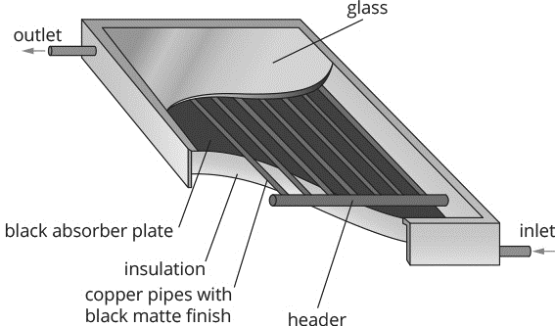

Why are the copper tubes and absorbing plate black? (1 mark)

Question 11

Double-glazed windows consist of two layers of glass that have a narrow air gap between them. In terms of heat transfer, state and explain two ways in which double-glazed windows reduce heat loss from homes. (4 marks)

(*To obtain full marks you need to state the heat transfer process(es), how it is changed and why)*

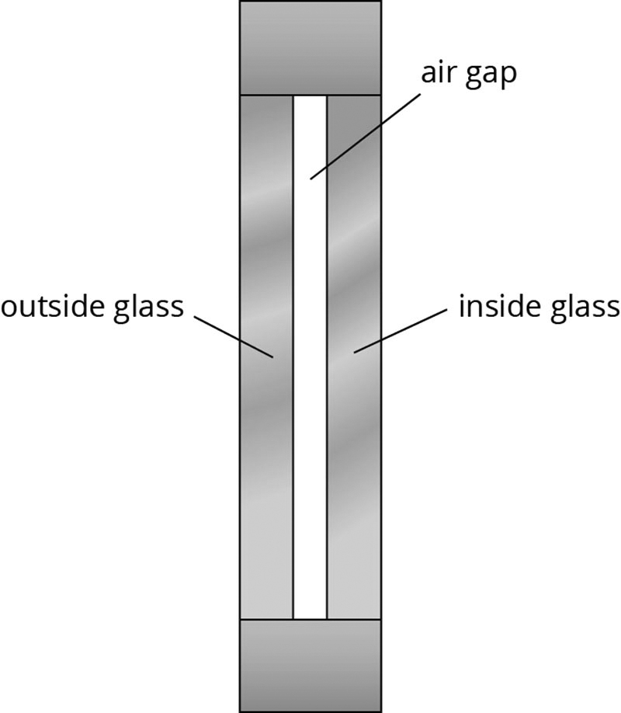

a)

b)

Question 12

The total energy supplied to a car in a given time is 800 kJ, and 360 kJ of this energy is usefully transformed.

a Calculate the efficiency of this car. (2 marks)

b The 440 kJ supplied to the engine that is not usefully transformed is called wasted energy. Name the two forms of energy produced by the engine that are classed as wasted energy. (1 mark)

